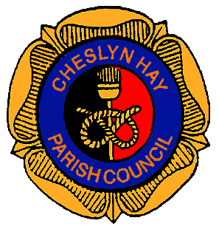
1the

CHESLYN HAY PARISH COUNCIL

Minutes of the
PARISH COUNCIL MEETING
held on Wednesday 4th July 2018
at the Village Hall, Pinfold Lane, Cheslyn Hay at 7.00 pm

1. 04/07/47 - MEMBERS PRESENT

1.1 Councillor E. A. Davison (Chair)
Councillors :- B. L. Bladen, J. C. Davison, A. W. Emery
Melanie Brown – Parish Clerk

2. 04/07/48 – APOLOGIES

2.1 Apologies for absence from Councillors P. Appleby, P. L. Appleton, R. Denson,
L. Emery, S. Hollis, G. Keatley, A. Pugh (Mrs), C. Wilkinson (Mrs),
P. Wilkinson and B. Woolley.

2.2 As the meeting was not quorate the meeting closed at 7.10 pm.

3. 04/07/49 – PUBLIC PARTICIPATION

A member of the public was in attendance to speak at the Public Participation session. The Chair explained that this was not now available, however the resident was happy to discuss his issues with Morris Homes at New Horse Road with the Chair and Members in attendance.

Page 1 of 1 Chairman’s Signature ………………………………………

